Surety is the heartbeat of a construction company.

The ability to get a surety bond… when you need it… for the right amount… is the lifeblood of survival. Many people believe that is as simple as setting up an account. However, the truth is that the surety market and construction environment is an ever evolving world. Frequent changes take place in the surety space as to cash requirements, balance sheet expectations, WIP management, and type of work. The worst thing that could happen would be to find out the best job you have ever seen can’t be done because you can’t get bonded.

At INSURANCE AGENCY NAME, we have developed a system that proactively manages surety for a contractor to give them confidence they will have the best financial structure and best surety relationship to get the surety bonds when they need them.

The Surety Performance System™ will conduct a thorough assessment of your financials, current operational plans, future growth plans, as well as complete an annual plan for maximizing your potential.

Our overall goals are to help you:

- Secure Larger Jobs
- Increase Bond Capacity
- Have backup in place for increased security of getting that critical bond
- Maintain great relationships with surety underwriters
- Be proactive vs reactive in the surety bond market

The Surety Performance System™

- Initial Surety Review
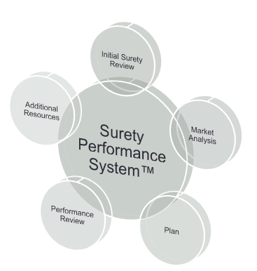
  - Financial review and benchmark
  - Credit analysis
  - Current work
  - Work performance review
  - Projected and future work plan
  - Capacity review
  - Backup review
- Market Analysis
  - Trends in the market place
  - Quarterly update
  - Proprietary market data
  - Bond credit management
- Plan
  - Consulting advice
  - Surety improvement strategies
  - Financial recommendations
- Performance Review
  - Review results of plan
  - Determine what is working
  - Determine what is not working
- Additional Resources
  - Crisis management
  - Business perpetuation planning
  - Business continuity planning
  - Coordination of risk control and insurance services

