Name: Date:
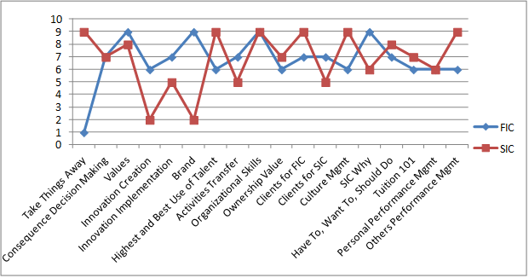

Gaps
- Take Things Away
- Innovation Creation
- Brand
- Clients for FIC
- Others Performance Management
Strengths
- Consequence Decision Making
- Values
- Organizational Skills
Areas for Development
- Innovation Creating
- Innovation Implementation
- Brand

Summary and Recommendations
- This is a very typical report. Communication of expectations and proactively managing things that will make the noise go away are missing
- The second in command is performing relatively well. Job expectations and the execution of what the SIC does best, is outstanding
- The SIC has a very strong WHY and motivation to do what is right is never in question
- 5 areas that are not seen equally by the FIC/SIC and 7 areas needed to improve to maximize SIC performance. This is a large amount of items that could be making an impact on the FIC and making the noise go away
- We recommend the NRS™ course if 1/3 or more of the items are either gaps in communication/clarity or areas for development. 12 items to improve on communication or execution is certain to bring a large value to the organization
- We need to determine the ROI in these specific areas, begin the class, and monitor the progress

